**JAVASCRIPT**

**1. Create a student registration form. Create functions to perform the following checks:**

1. **Roll number is a 7 digit numeric value**
2. **Name should be end alphabetical value (String)**
3. **DOB entered in mm/dd/yy format and should be display in words (e.g. Saturday, January 01, 2000)**
4. **Check on non-empty fields**

CODE

<html>

<head>

<title>Student Registration</title>

<script type="text/javascript">

function checkName(event)

{

var a=event.keyCode;

var x=document.getElementById("2").value.length;

if(!((a>64 && a<91) || (a==16)))

{

document.getElementById("2").value=document.getElementById("2").value.slice(0,x-1);

}

}

function checkRoll(event)

{

var a=event.keyCode;

var x=document.getElementById("1").value.length;

if(x>7)

{

document.getElementById("1").value=document.getElementById("1").value.slice(0,x-1);

}

}

function checkDate()

{

var d=document.getElementById("3").value;

if(d=="") alert("Please select a date");

else

{

var r = document.getElementById("1").value;

var n = document.getElementById("2").value;

var d = document.getElementById("3").value;

var dob = new Date(document.getElementById("3").value);

var days = new Array("Sunday","Monday","Tuesday","Wednesday","Thursday","Friday","Saturday");

var months = new Array("January","February","March","April","May","June","July","August","September","October","November","December");

var day = dob.getDay();

var month = dob.getMonth();

var dobstr = days[day] + " " + months[month] + " " + dob.getDate() + ", " + dob.getFullYear();

if(r != "" && n != "" && d != "")

{

document.write("Name : " + document.getElementById("2").value + "<br>Roll no. : " + document.getElementById("1").value + "<br>Date : " + dobstr);

}

else if(document.getElementById("1").value == "")

{

alert("Roll no. field empty");

document.getElementById("1").focus();

}

else if(document.getElementById("2").value == "")

{

alert("Name field empty");

document.getElementById("2").focus();

}

else if( d == "" )

{

alert("Date field empty");

document.getElementById("3").focus();

}

}

}

</script>

</head>

<body>

<form>

Name : <input type="text" id="2" onkeyup="checkName(event)"><br><br>

Roll No. : <input type = "number" id="1" onkeyup="checkRoll(event)"><br><br>

DOB : <input type="date" id="3"><br><br>

<input type="button" value="Submit" onclick="checkDate()">

</form>

</body>

</html>

OUTPUT

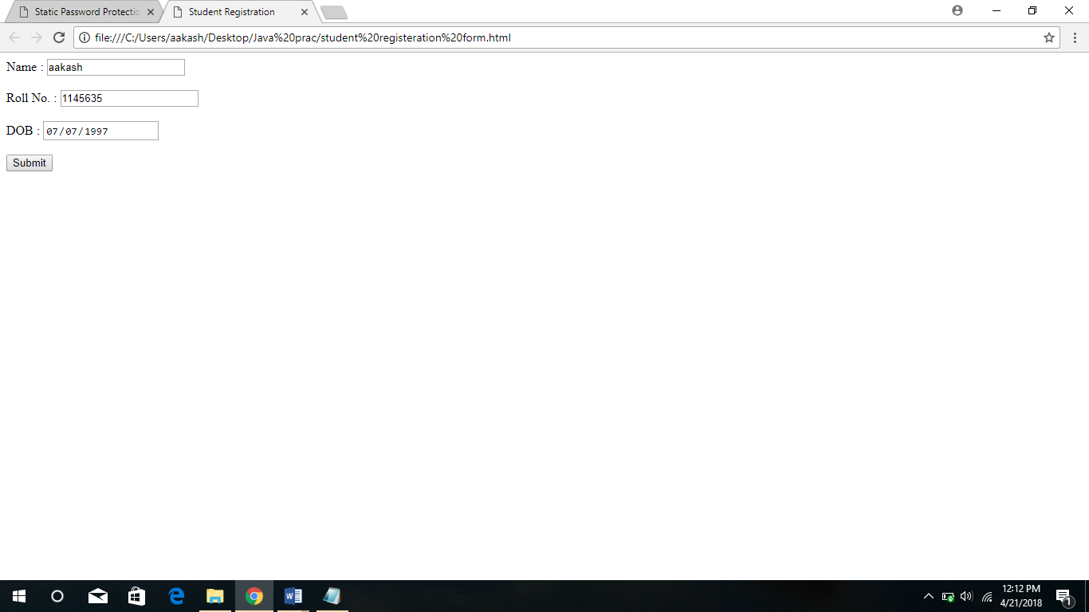

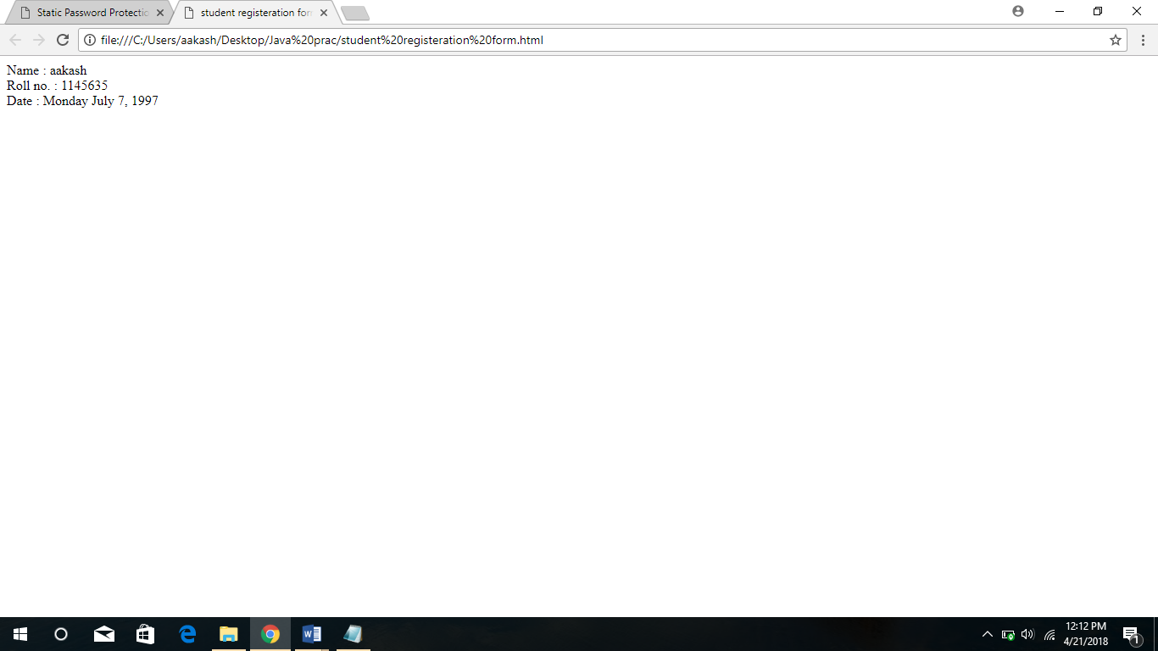

Q2. Implement a static password protection.

**CODE**

<html>

<head>

<title>Static Password Protection</title>

<script>

function check()

{

var user = document.getElementById("Username").value;

var pass = document.getElementById("Password").value;

if (user=="Aakash" && pass=="Password")

{ alert("Successful Login"); }

else

{ alert("Please Try Again"); }

}

</script>

</head>

<body>

<form>

Enter Username : <input type="text" id="Username"> <br><br>

Enter Password : <input type="password" id="Password"> <br><br>

<input type="button" value="Submit" onClick="check()">

</form>

</body>

</html>

OUTPUT

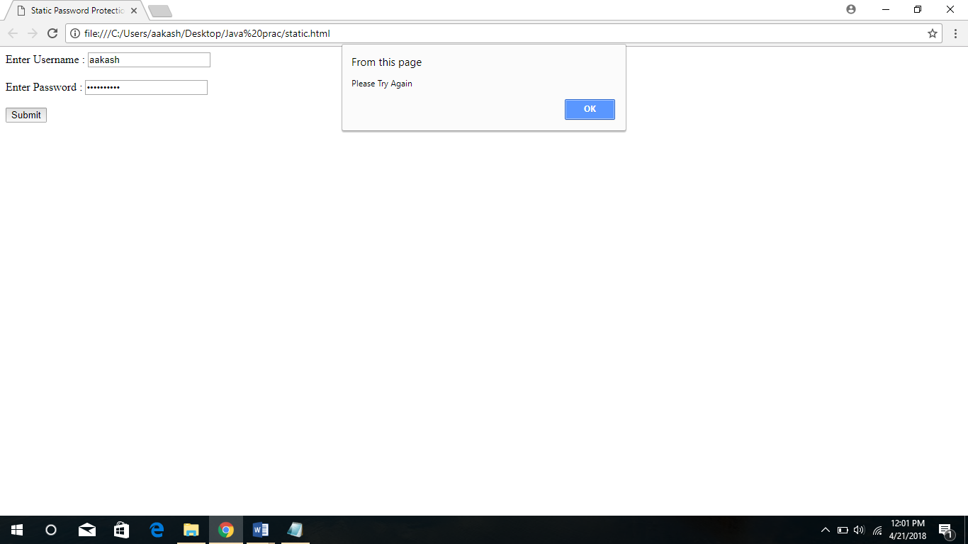

Q3. **Write a JavaScript**

1. **to change the colour of text using setTimeOut()**

**SOURCE CODE**

* **color.html**

<html>

<head>

<title>Changing Color</title>

<script>

onload = setTimeout( function() { document.getElementById("txt").style.color = "Red"; }, 2000);

</script>

</head>

<body>

<p id="txt"> Changing Text Color</p>

</body>

</html>

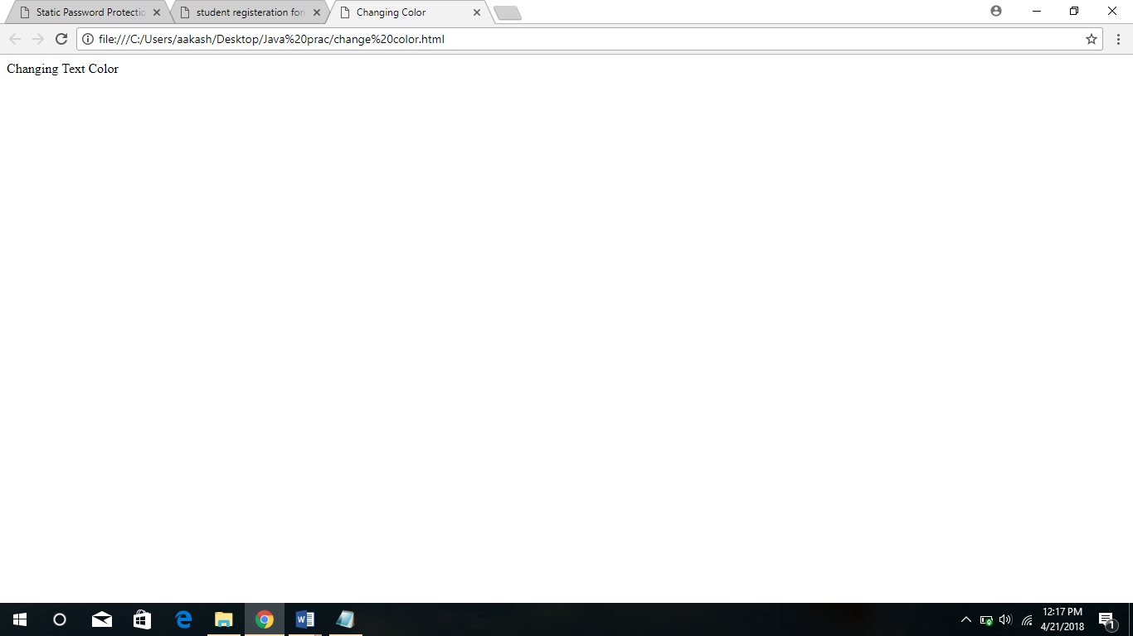

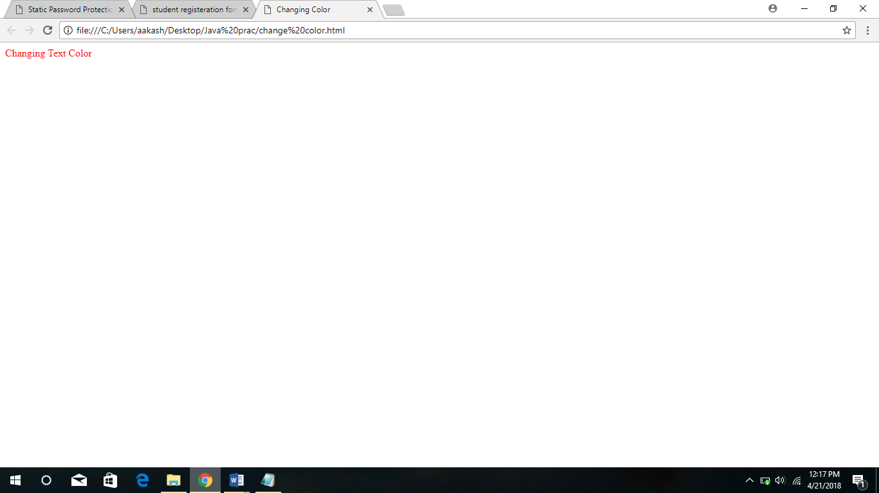

1. **to move an image across screen using setInterval()**

**CODE**

<html>

<head>

<title>Moving Image</title>

<script>

var x = 0;

setInterval(Run,5);

function Run(){

img1 = document.getElementById("i1");

if (x < window.screen.width) x += 1;

else x = 0;

img1.style.left = x + "px";

}

</script>

</head>

<body style="overflow:hidden">

<img id="i1" src = "img1.jpg" style="position:absolute">

</body>

</html>

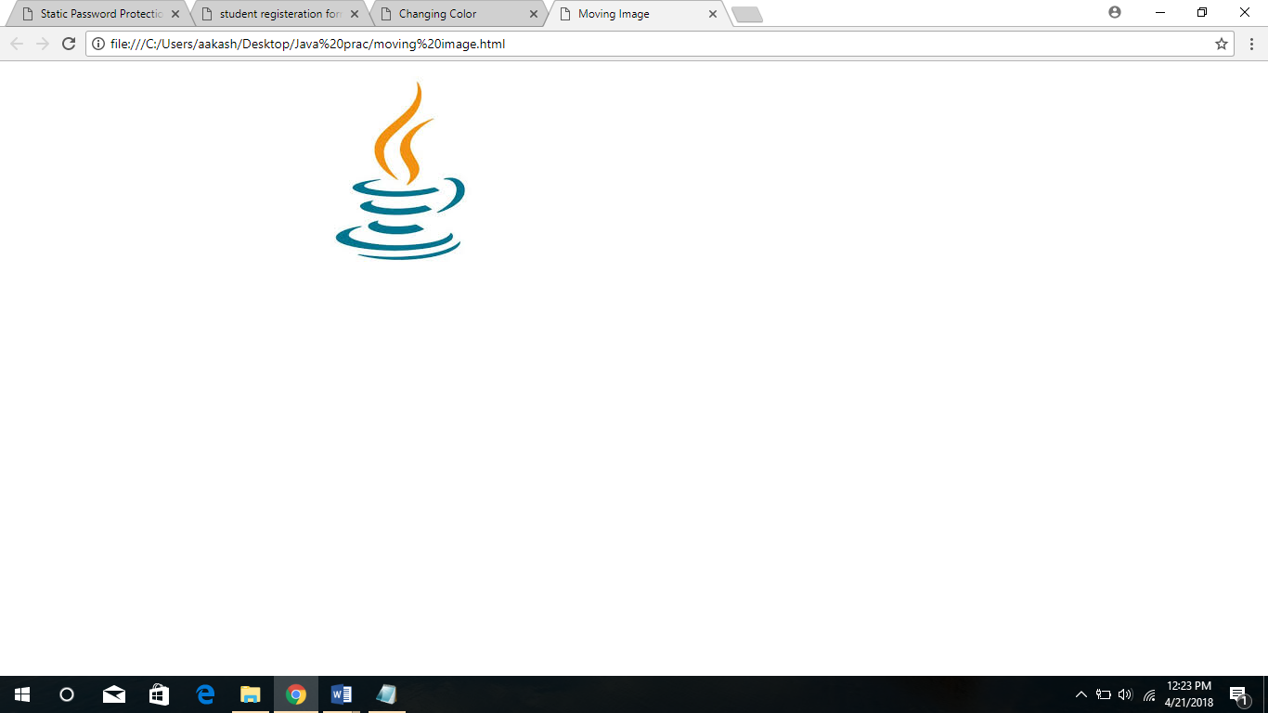

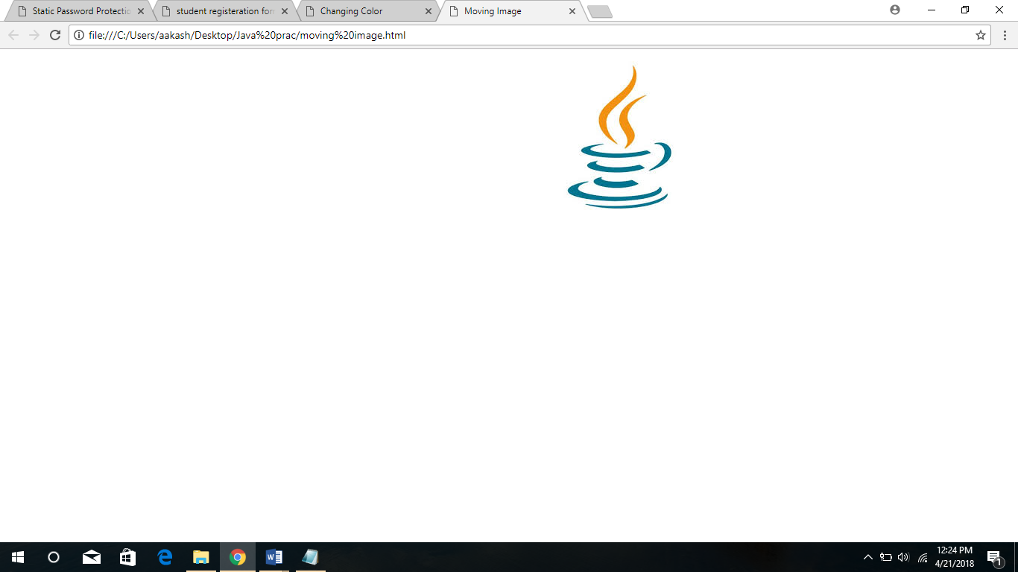

**JSP**

**1. Display the pattern:**

**1**

**1 2**

**1 2 3**

**Take ‘n’ in a text box from user. Display this pattern using**

* **Scriplets**
* **<c :forEach> loop**

**SOURCE CODE**

* **index.html**

<html>

<head>

<title>Using Scriplets</title>

</head>

<body>

<form action="series.jsp" method="get">

Enter value of n : <input type="number" name="num"><br><br>

<input type="submit">

</form>

</body>

</html>

* **index2.html**

<html>

<head>

<title>Using forEach</title>

</head>

<body>

<form action="series2.jsp" method="get">

Enter value of n : <input type="number" name="num"><br><br>

<input type="submit">

</form>

</body>

</html>

* **series.jsp**

<html>

<head>

<title>Using Scriplets</title>

</head>

<body>

<% int n = Integer.parseInt(request.getParameter("num"));

for(int i=1;i<=n;i++)

{

for(int j=1;j<=i;j++)

{

out.println(j+"\t");

}

out.println("<br>");

}

%>

</body>

</html>

* **series2.jsp**

<%@taglib prefix="c" uri="http://java.sun.com/jsp/jstl/core"%>

<%@taglib prefix="fmt" uri="http://java.sun.com/jsp/jstl/fmt"%>

<html>

<head>

<title>Using forEach</title>

</head>

<body>

<fmt:parseNumber var="n" type="number" value="${param.num}"/>

<c:forEach var="i" begin="1" end="${n}">

<c:forEach var="i" begin="1" end="${i}">

<c:out value="${i} "/>

</c:forEach>

<br>

</c:forEach>

</body>

</html>

**OUTPUT**

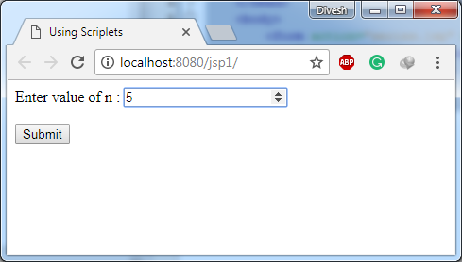

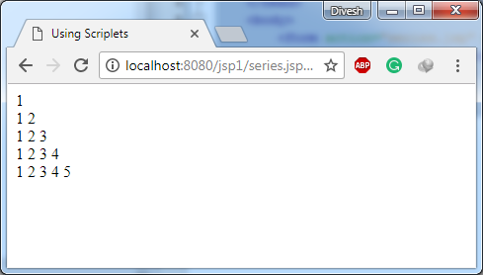

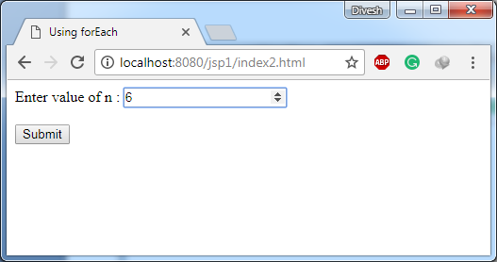

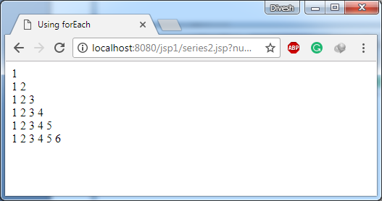

**2. Make two files as follows:**

1. **main.html: shows 2 text boxes and 3 radio buttons with values “addition”, “subtraction” and “multiplication”**
2. **Operate.jsp: depending on what the user selects perform the corresponding function (Give two implementations : using request.getParameter() and using expression language)**

**SOURCE CODE**

* **index.html**

<html>

<head>

<title>Using request.getParameter()</title>

</head>

<body>

<form action="menu.jsp" method="get">

Enter 1st operand : <input type="number" name="num1"><br><br>

Enter 2nd operand : <input type="number" name="num2"><br><br><br>

<b>Choose Operation</b><br><br>

<input type="radio" name="op" value="1"> Addition <br>

<input type="radio" name="op" value="2"> Subtraction <br>

<input type="radio" name="op" value="3"> Multiplication <br><br>

<input type="submit">

</form>

</body>

</html>

* **index2.html**

<html>

<head>

<title>Using Expression Language</title>

</head>

<body>

<form action="menu2.jsp" method="get">

Enter 1st operand : <input type="number" name="num1"><br><br>

Enter 2nd operand : <input type="number" name="num2"><br><br><br>

<b>Choose Operation</b><br><br>

<input type="radio" name="op" value="1"> Addition <br>

<input type="radio" name="op" value="2"> Subtraction <br>

<input type="radio" name="op" value="3"> Multiplication <br><br>

<input type="submit">

</form>

</body>

</html>

* **menu.jsp**

<html>

<head>

<title>Using request.getParameter()</title>

</head>

<body>

<% int a = Integer.parseInt(request.getParameter("num1"));

int b = Integer.parseInt(request.getParameter("num2"));

int op = Integer.parseInt(request.getParameter("op"));

switch(op)

{

case 1:

out.println("Sum is : "+(a+b));

break;

case 2:

out.println("Difference is : "+(a-b));

break;

case 3:

out.println("Product is : "+(a*b));

break;

}

%>

</body>

</html>

* **menu2.jsp**

<%@taglib prefix="c" uri="http://java.sun.com/jsp/jstl/core"%>

<html>

<head>

<title>Using Expression Language</title>

</head>

<body>

<c:choose>

<c:when test="${param.op==1}">

<c:out value = "Sum is : ${param.num1+param.num2}"/>

</c:when>

<c:when test="${param.op==2}">

<c:out value = "Difference is : ${param.num1-param.num2}"/>

</c:when>

<c:when test="${param.op==3}">

<c:out value = "Product is : ${param.num1*param.num2}"/>

</c:when>

</c:choose>

</body>

</html>

**OUTPUT**

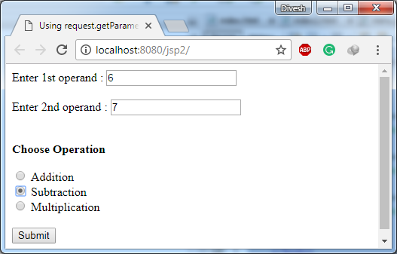

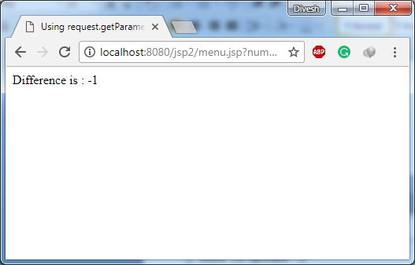

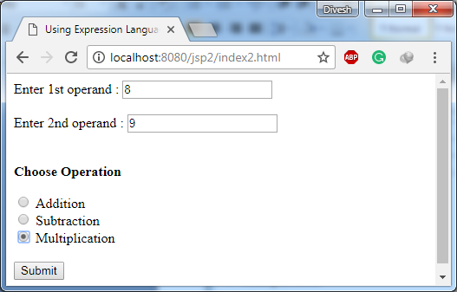

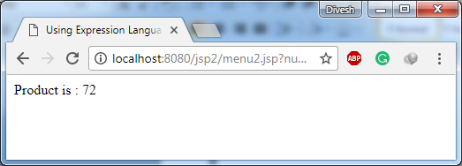

**3. Validate User input entered in a form. The input must include Name, DOB, Email ID, Lucky Number , Favorite food etc. (Refer Chapter 8)**

**SOURCE CODE**

* **index.jsp**

<%@ taglib prefix="c" uri="http://java.sun.com/jsp/jstl/core" %>

<html>

<head>

<title>User Info Entry Form</title>

</head>

<body>

<form action="index.jsp" method="post">

<input type="hidden" name="submitted" value="true">

<table>

<c:if test="${param.submitted && empty param.userName}">

<tr>

<td></td>

<td><font color="red">Please enter your Name</font></td>

</tr>

</c:if>

<tr>

<td>Name:</td>

<td>

<input type="text" name="userName" value="${param.userName}">

</td>

</tr>

<c:if test="${param.submitted && empty param.birthDate}">

<tr>

<td></td>

<td><font color="red">Please enter your Birth Date</font></td>

</tr>

</c:if>

<tr>

<td>Birth Date:</td>

<td><input type="text" name="birthDate" value="${param.birthDate}"></td>

<td>(Use format yyyy-mm-dd)</td>

</tr>

<c:if test="${param.submitted && empty param.emailAddr}">

<tr>

<td></td>

<td><font color="red">Please enter your Email Address</font></td>

</tr>

</c:if>

<tr>

<td>Email Address:</td>

<td><input type="text" name="emailAddr" value="${param.emailAddr}"></td>

<td>(Use format name@company.com)</td>

</tr>

<c:if test="${param.submitted && param.gender != 'm' && param.gender != 'f'}">

<tr>

<td></td>

<td><font color="red">Please select a valid Gender</font></td>

</tr>

</c:if>

<tr>

<td>Gender:</td>

<td>

<c:choose>

<c:when test="${param.gender == 'f'}">

<input type="radio" name="gender" value="m">Male<br>

<input type="radio" name="gender" value="f" checked>Female

</c:when>

<c:otherwise>

<input type="radio" name="gender" value="m" checked>Male<br>

<input type="radio" name="gender" value="f">Female

</c:otherwise>

</c:choose>

</td>

</tr>

<c:if test="${param.submitted && (param.luckyNumber < 1 || param.luckyNumber > 100)}">

<tr>

<td></td>

<td><font color="red">Please enter a Lucky Number between 1 and 100</font></td>

</tr>

</c:if>

<tr>

<td>Lucky number:</td>

<td><input type="text" name="luckyNumber" value="${param.luckyNumber}"></td>

<td>(A number between 1 and 100)</td>

</tr>

<c:forEach items="${paramValues.food}" var="current">

<c:choose>

<c:when test="${current == 'z'}">

<c:set var="pizzaSelected" value="true" />

</c:when>

<c:when test="${current == 'p'}">

<c:set var="pastaSelected" value="true" />

</c:when>

<c:when test="${current == 'c'}">

<c:set var="chineseSelected" value="true" />

</c:when>

<c:otherwise>

<c:set var="invalidSelection" value="true" />

</c:otherwise>

</c:choose>

</c:forEach>

<tr>

<td>Favorite Foods:</td>

<td><input type="checkbox" name="food" value="z" ${pizzaSelected ? 'checked' : ''}>Pizza<br>

<input type="checkbox" name="food" value="p" ${pastaSelected ? 'checked' : ''}>Pasta<br>

<input type="checkbox" name="food" value="c" ${chineseSelected ? 'checked' : ''}>Chinese

</td>

</tr>

<tr>

<td><input type="submit"></td>

</tr>

</table>

</form>

</body>

</html>

**OUTPUT**

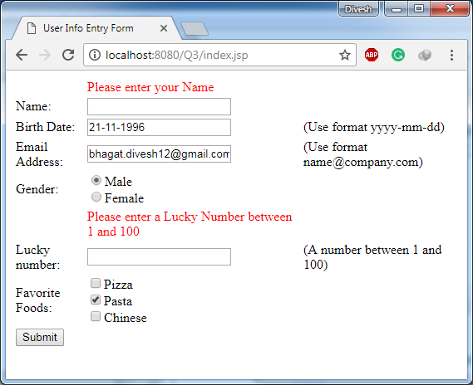

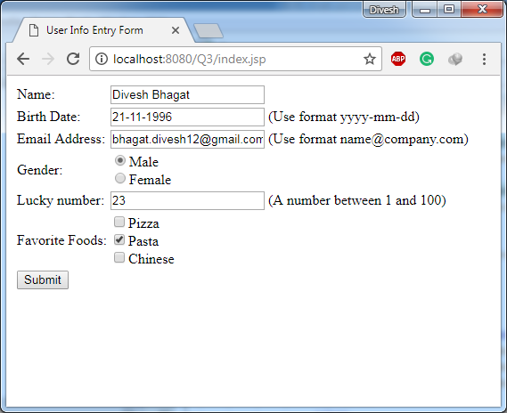

**4. Display Good Morning <uname>, Good Afternoon <uname> or Good evening<uname> based on the current time of the day.**

**SOURCE CODE**

* **index.html**

<html>

<head>

<title>Display appropriate message using current time</title>

</head>

<body>

<form action="run.jsp" method="get">

<input type="submit">

</form>

</body>

</html>

* **run.jsp**

<%@taglib prefix="m" uri="/WEB-INF/tlds/tag4.tld"%>

<html>

<head>

<title>Display appropriate message using current time</title>

</head>

<body>

<m:msg/>

</body>

</html>

* **tag4.tld**

<taglib>

<tlib-version>1.0</tlib-version>

<jsp-version>2.1</jsp-version>

<short-name>tag4</short-name>

<tag>

<name>msg</name>

<tag-class>message.MsgTag</tag-class>

<body-content>scriptless</body-content>

</tag>

</taglib>

* **MsgTag.java**

package message;

import java.io.*;

import java.util.Date;

import javax.servlet.jsp.*;

import javax.servlet.annotation.WebServlet;

import javax.servlet.jsp.tagext.SimpleTagSupport;

@WebServlet(urlPatterns = {"/MsgTag"})

public class MsgTag extends SimpleTagSupport {

public void doTag() throws JspException,IOException{

JspWriter out = getJspContext().getOut();

Date d = new Date();

if(d.getHours()<12) out.println("Good Morning");

else if(d.getHours()<17) out.println("Good Afternoon");

else out.println("Good Evening");

}

}

**OUTPUT**

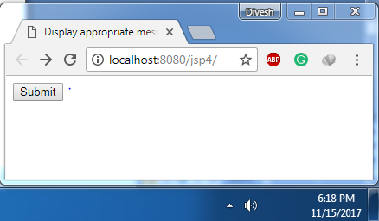

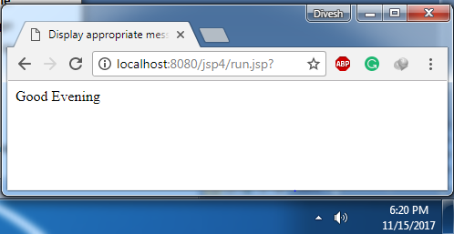

**5. Create your custom library which contains two tags: <hello>, <choco>.**

**Usage of the tags:**

* **<hello name=”Ajay”>: Output should be Hello Ajay. It contains a mandatory attribute ‘name’ which can accept Dynamic value.**
* **<choco texture=”Chewy”>: Output should be FiveStar, BarOne.**
* **<choco texture=”Crunchy”>: Output should be Munch, KitKat.**

**That means the mandatory attribute must accept a value, and based on the attributes value, it should give output.**

**SOURCE CODE**

* **index.html**

<html>

<head>

<title>Hello and Choco tag</title>

</head>

<body>

<form action="run.jsp" method="get">

Enter name : <input type="text" name="name"><br><br>

<input type="submit">

</form>

</body>

</html>

* **run.jsp**

<%@taglib prefix="r" uri="WEB-INF/tlds/tag6.tld"%>

<html>

<head>

<title>Hello and Choco tag</title>

</head>

<body>

<r:hello name="${param.name}"/>

<r:choco texture="Crunchy"/>

</body>

</html>

* **tag6.tld**

<taglib>

<tlib-version>1.0</tlib-version>

<jsp-version>2.1</jsp-version>

<short-name>tag6</short-name>

<tag>

<name>hello</name>

<tag-class>jsp6.HelloTag</tag-class>

<attribute>

<name>name</name>

<required>true</required>

<rtexprvalue>true</rtexprvalue>

</attribute>

<body-content>scriptless</body-content>

</tag>

<tag>

<name>choco</name>

<tag-class>jsp6.ChocoTag</tag-class>

<attribute>

<name>texture</name>

<required>true</required>

</attribute>

<body-content>scriptless</body-content>

</tag>

</taglib>

* **HelloTag.java**

package jsp6;

import javax.servlet.jsp.*;

import java.io.*;

import javax.servlet.annotation.WebServlet;

import javax.servlet.jsp.tagext.SimpleTagSupport;

@WebServlet(urlPatterns = {"/HelloTag"})

public class HelloTag extends SimpleTagSupport

{

String n;

public void setName(String a)

{

n = a;

}

public void doTag() throws JspException,IOException

{

JspWriter out = getJspContext().getOut();

out.println("Hello "+n+".<br><br>");

}

}

* **ChocoTag.java**

package jsp6;

import javax.servlet.jsp.*;

import java.io.*;

import javax.servlet.annotation.WebServlet;

import javax.servlet.jsp.tagext.SimpleTagSupport;

@WebServlet(urlPatterns = {"/ChocoTag"})

public class ChocoTag extends SimpleTagSupport

{

String t;

public void setTexture(String b)

{

t = b;

}

public void doTag() throws JspException,IOException

{

JspWriter out = getJspContext().getOut();

if (t=="Chewy") out.println("FiveStar, BarOne.");

else if (t=="Crunchy") out.println("Munch, KitKat.");

}

}

**OUTPUT**

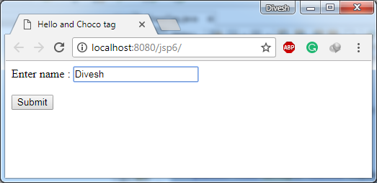

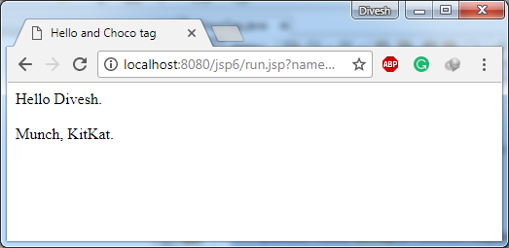

**JAVA**

Q1. WAP to find out largest number from n numbers.

|  |  |
| --- | --- |
| PROGRAM | OUTPUT |
| import java.util.Scanner;  public class LargestNaturalNumber {  public static void main(String[] args) {  Scanner sc=new Scanner(System.in);  int i=sc.nextInt();  int a[]=new int[i];  int j;  System.out.println("Enter the elements of the array: ");  for (j=0;j<i;j++) a[j]=sc.nextInt();  int max=a[0];  for (j=0;j<i;j++){  if (max<a[j]) max=a[j];  }  System.out.println("The largest natural number in this array is "+max+".");  }  } | run:  5  Enter the elements of the array:  10  12  14  16  18  The largest natural number in this array is 18.  BUILD SUCCESSFUL (total time: 10 seconds) |

Q2. WAP to find whether given number is prime or not?

|  |  |
| --- | --- |
| PROGRAM | OUTPUT |
| import java.util.Scanner;  public class prime {  public static void main(String[] args){  Scanner sc=new Scanner(System.in);  System.out.println("Enter a number: ");  int num=sc.nextInt();  for(int i=2;i<=num/2;i++){  if(num%i==0){  System.out.println("The number is not prime");  break;  }  else if(i==num/2){  System.out.println("The number is prime ");  }  }  }  } | run:  Enter a number:  31  The number is prime  BUILD SUCCESSFUL (total time: 5 seconds) |

Q3. WAP to find the sum and product of digits of that number.

|  |  |
| --- | --- |
| PROGRAM | OUTPUT |
| import java.util.Scanner;  public class SumProdDigits {  public static void main(String[] args){  Scanner sc=new Scanner(System.in);  int i=sc.nextInt();  int j=0,n,m=1,z=0,k=0;  while (i>0){  if (i>j){  n=i%10;  m*=n;  z+=n;  k=k*10+I;  }  i=i/10;  }  System.out.println("The product of digits is "+m+".");  System.out.println(“The sum of digits is“+z+”.”);  System.out.println(“The reverse of digit is”+k+”.”);  }  } | run:  369  The product of digits is 162.  BUILD SUCCESSFUL (total time: 7 seconds) |

Q4. Write a program to create an array of 10 integers. Accept values from the user in that array. Input another number from the user and find out how many numbers are equal to the number passed, how many are greater and how many are less than the number passed.

|  |  |
| --- | --- |
| PROGRAM | OUTPUT |
| import java.util.Scanner;  public class BigSmall {  public static void main(String[] args){  Scanner sc=new Scanner(System.in);  int []a=new int[10];  int equ=0,gre=0,les=0;  for(int j=0;j<10;j++){  System.out.println("Enter the number in array");  a[j]=sc.nextInt();  }  System.out.println("Enter the number ypu want to compare");  int n=sc.nextInt();  for(int j=0;j<10;j++){  if(n==a[j]){  equ++;  }  else if(n>a[j]){  gre++;  }  else  les++;  }  System.out.println("Numbers greater than "+n+" are "+gre+".");  System.out.println("Numbers lesser than "+n+" are "+les+".");  System.out.println("Numbers equal to "+n+" are "+equ+".");  }  } | run:  Enter the number in array  10  Enter the number in array  11  Enter the number in array  12  Enter the number in array  13  Enter the number in array  14  Enter the number in array  15  Enter the number in array  16  Enter the number in array  17  Enter the number in array  18  Enter the number in array  19  Enter the number ypu want to compare  15  Numbers greater than 15 are 5.  Numbers lesser than 15 are 4.  Numbers equal to 15 are 1.  BUILD SUCCESSFUL (total time: 18 seconds) |

Q5. WAP to multiply, add, subtract two matrices.

|  |  |
| --- | --- |
| PROGRAM | OUPUT |
| import java.util.Scanner;  public class matrix1 {  public static void main(String[] args){  System.out.println("Enter the number of rows in first matrix");  Scanner sc=new Scanner(System.in);  int a=sc.nextInt();  System.out.println("Enter the number of columns in first matrix");  int b=sc.nextInt();  int [][] m=new int[a][b];  System.out.println("Enter the elements of matrix row wise");  for(int i=1;i<=a;i++){  for(int j=1;j<=b;j++){  m[i][j] =sc.nextInt();  }  }  int sum=0;  System.out.println("Enter the number of rows in second matrix");  int c=sc.nextInt();  System.out.println("Enter the number of columns in second matrix");  int d=sc.nextInt();  int [][] n=new int[c][d];  System.out.println("Enter the elements of matrix row wise");  for(int i=1;i<=c;i++){  for(int j=1;j<=d;j++){  n[i][j] =sc.nextInt();  }  }  if(a==c&b==d){  System.out.println("Matrix operations"  + "1.Addition"  + "2.Subtraction"  + "3.Transpose ");  System.out.println("Enter the number of operation");  int e=sc.nextInt();  if(e==1){  int[][] z=new int[a][d];  for(int i=1;i<=a;i++){  for(int j=1;j<=d;j++){  z[i][j]=m[i][j]+n[i][j];  }  }  System.out.println("The resultant matrix is");  for(int i=1;i<=a;i++){  for(int j=1;j<=d;j++){  System.out.println(z[i][j]+"\t");  }  System.out.print("\n");  }  }  else if(e==2){  int[][] z=new int[a][d];  for(int i=1;i<=a;i++){  for(int j=1;j<=d;j++){  z[i][j]=m[i][j]-n[i][j];  }  }  System.out.println("The reultant matrix is");  for(int i=1;i<=a;i++){  for(int j=1;j<=d;j++){  System.out.println(z[i][j]+"\t");  }  System.out.print("\n");  }  }  else if(e==3){  int[][] z=new int[a][d];  for(int i=1;i<=a;i++){  for(int j=1;j<=d;j++){  z[j][i]=m[i][j];  }  }  }  System.out.println("The reultant matrix is");  for(int i=1;i<=a;i++){  for(int j=1;j<=d;j++){  System.out.println(z[i][j]+"\t");  }  System.out.print("\n");  }  }  else  System.out.println("You had entered the wrong number");  }  else  System.out.println("The numbers of row of first matrix and column of second matrix is not equal");  }  } | run:  Enter the number of rows in first matrix  2  Enter the number of columns in first matrix  2  Enter the elements of matrix row wise  1  2  3  4  Enter the number of rows in second matrix  2  Enter the number of columns in second matrix  2  Enter the elements of matrix row wise  1  2  3  4  Matrix oprations1.Addition2.Subtraction3.Multoplication  Enter the number of operation  1  The resultant matrix is  2 4  6 8  BUILD SUCCESSFUL (total time: 15 seconds) |

Q6 write a java program that computes the area of circle, rectangle, cylinder using function overloading.

|  |  |
| --- | --- |
| PROGRAM | OUTPUT |
| import java.util.Scanner;  class overload{  void area(float x,float y)  {  System.out.println("the area of the rectangle is "+x*y+" sq units");  }  void area(double b,double c)  {  double z=2*3.14*b*(b+c);  System.out.println("the area of the cylinder is "+z+" sq units");  }  void area(double x)  {  double z = 3.14 * x * x;  System.out.println("the area of the circle is "+z+" sq units");  }  }  public class area {  public static void main(String[] args){  Scanner sc=new Scanner(System.in);  System.out.println("Area menu"  + "1.Area of Rectangle"  + "2.Area of Cylinder"  + "3.Area of Circle");  int x=sc.nextInt();  if(x==1){  System.out.println("Enter the length of rectangle");  float l=sc.nextInt();  System.out.println("Enter the length of rectangle");  float b=sc.nextInt();  overload ob = new overload();  ob.area(l,b);  }  if(x==2){  System.out.println("Enter the radius of cylinder");  double r=sc.nextInt();  System.out.println("Enter the height of cylinder");  double b=sc.nextInt();  overload ob = new overload();  ob.area(r,b);  }  if(x==3){  System.out.println("Enter the radius of cylinder");  double r=sc.nextInt();  overload ob = new overload();  ob.area(r);  }  else{  System.out.println("You have entered wrong number");  }  }  } | run:  Area menu1.Area of Rectangle2.Area of Cylinder3.Area of Circle  2  Enter the radius of cylinder  10  Enter the height of cylinder  10  the area of the cylinder is 1256.0 sq units  You have entered wrong number  BUILD SUCCESSFUL (total time: 15 seconds) |

**JDBC**

**2. Create a procedure in MySQL to count the number of Rows in table ‘Student’. Use CallableStatement to call this method from Java code.**

**SOURCE CODE**

* **Student2.java**

package student2;

import java.sql.*;

public class Student2

{

public static void main(String[] args) throws ClassNotFoundException, SQLException

{

String JDBC_DRIVER = "com.mysql.jdbc.Driver";

String DB_URL = "jdbc:mysql://localhost:3306/student";

Class.forName(JDBC_DRIVER);

Connection conn = DriverManager.getConnection(DB_URL,"root","root");

String sql = "{call getCount (?)}";

CallableStatement stmt = conn.prepareCall(sql);

stmt.registerOutParameter(1, java.sql.Types.INTEGER);

stmt.execute();

int count = stmt.getInt(1);

System.out.println("Total number of students : " + count);

stmt.close();

conn.close();

}

}

**OUTPUT**

